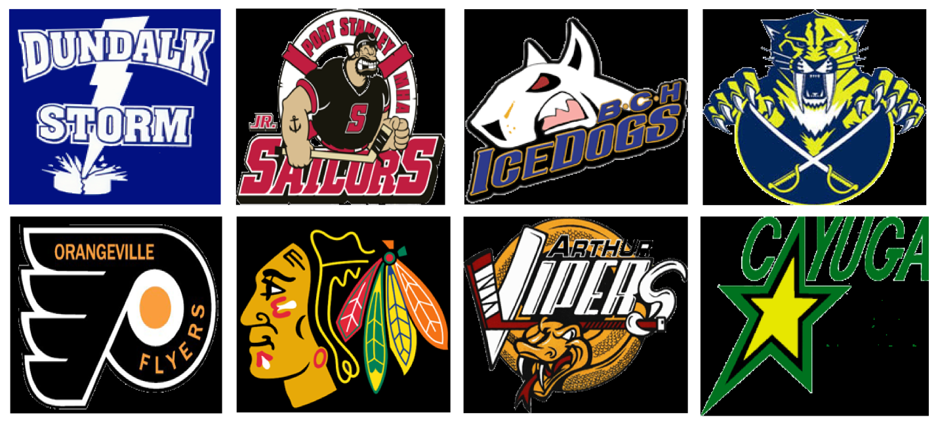
2ND ANNUAL SHOW DOWN IN "D" TOWN TOURNAMEnT
SCHEDULE
GAME #1 8:00AM WALLACE SABRES VS ORANGEVILLE FLYERS
GAME #2 9:00AM ARTHUR VIPERS VS COLLINGWOOD BLACKHAWKS
GAME #3 10:00AM DUNDALK STORM VS BCH ICE DOGS
GAME #4 11:00AM PORT STANLEY JR SAILORS VS CAYUGA STARS
GAME #5 12:00PM L GAME #1 VS L GAME #3
GAME #6 1:00PM L GAME #2 VS L GAME #4
GAME #7 2:00PM W GAME #1 VS W GAME #3
GAME #8 3:00PM W GAME #2 VS W GAME #4
GAME #9 4:00PM D CHAMPIONSHIP L GAME #5 VS L GAME #6
GAME #10 5:00PM C CHAMPIONSHIP L GAME #7 VS L GAME #8
GAME #11 6:00PM B CHAMPIONSHIP W GAME #5 VS W GAME #6
GAME #12 7:00PM A CHAMPIONSHIP W GAME #7 VS W GAME #8

